

School of Public Administration  
Bachelor of Science in Computing

**COMP492 Final Year Project  
Final Report**Academic Year 2018/19

|  |  |
| --- | --- |
| Video-based Automatic Attendance Checking System with Face Anti-Spoofing Test | |
|  |  |
| Project number: | 39 |
| Student ID: | P15-0785-9 |
| Student Name: | Tianyi Zheng |
|  |  |
| Supervisor: | Dr. Yapeng Wang |
| Assessor: | Mr. Kahou |
|  |  |
| Submission Date: | Apr. 12, 2019 |

Declaration of Originality

I, Tianyi Zheng, declare that this report and the work reported herein was composed by and originated entirely from me. This report has not been submitted in any form for another degree or diploma at any university or other institutes of tertiary education. Information derived from the published and unpublished work of others has been acknowledged in the text and a list of references is given in the bibliography.

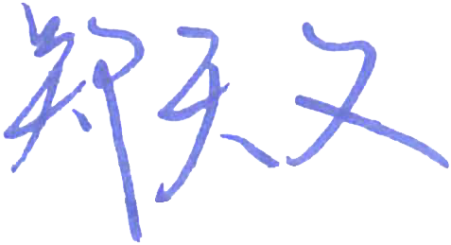

Mar. 5, 2019

Abstract

Nowadays, biometric identification has developed rapidly and has been widely used in the various field. Especially for face recognition, it has received a huge amount of attention recently during the past few years. This kind of facial recognition technology could fulfil many contemporary needs for authentication and verification of identity. Since the traditional attendance checking consumes an amount of teaching time, it will be replaced in a more efficient way.

This project develops an automatic attendance checking system by implementing face recognition technology in order to reduce the time spent on the attendance checking and the professor will have more precious teaching time. An anti-spoofing test will also be implemented for dealing with access control to perform security authentication. The facial recognition system consists of a dataset which stores 40 face photos per user, pre-trained face embeddings through a convolutional neural network with the help of the previous dataset, and a face recognizer which trained on top of the above embeddings. In addition, the face dataset could be updated automatically since every time the users checked attendance successfully. The entire system is written using Python as the programming language and the database which stores the class information is implemented using MySQL. Facial recognition system and anti-spoofing test along with a friendly software interface and a database make up the automatic attendance checking system.

From the test results, this video-based attendance checking system works perfectly. The system firstly loads the information about the class from the database, then the live video stream will start. Face recognition function could recognize the user within 8 seconds and the result of the recognition is 83% correct. After a user is recognized, the anti-spoofing test would come up and it also functions well for ensuring the security of authentication. And the face dataset would be updated automatically in case of the user was recognized and passed the anti-spoofing test.

For further works, at first, it is important to expand the face dataset from multi-dimensions so that the accuracy of the face recognition function would be improved significantly. Moreover, since the automated update mechanism is adopted, reducing the size of face dataset would also be another serious challenge. Lastly, improving the photographic resolution of the camera in order to make the results of face recognition and eye blink detection more and more accurate is also a critical issue.

Acknowledgement

This report would not exist if not for the support and guidance of a special group of people who will always have my deepest appreciation.

I would like to thank Dr. Yapeng Wang, my project supervisor, who has offered his/her technical supports and guided me into this research.

I would like to thank Mr. Ka Hou who has been the assessor of my report.

I would like to thank my classmates and friends in the Computing Program of Macao Polytechnic Institute.

I cannot find words strong enough to express my appreciations for my family.

Table of Contents

1 Introduction 8

1.1 Objectives 9

1.2 Risk Assessment 11

1.3 Summary 13

2 Background and Related Work 14

2.1 Background 14

2.1.1 Python 14

2.1.2 OpenCV 14

2.1.3 FaceNet 15

2.1.4 SVM 17

2.1.5 Facial Point Annotation 17

2.2 Related Work 18

3 Design Approach 20

3.1 System Overview 20

3.2 System Workflow 21

3.3 Face Recognition Function 22

3.4 Face Anti-Spoofing Test 23

3.5 Automated Update of Face Dataset 23

3.6 Database Design 24

4 Implementation 25

4.1 Platforms 25

4.2 Face Recognition Function 25

4.2.1 Face Enrollment 26

4.2.2 Embeddings Extracting 26

4.2.3 Train Face Recognition Model 28

4.2.4 Face Recognition Function 29

4.3 Face Anti-Spoofing Test 30

4.4 Automated Update of Face Dataset 32

5 Results and Discussion 33

5.1 Results 33

5.1.1 Result of Face Enrollment 33

5.1.2 Home page 34

5.1.3 Result of Face Recognition Function 35

5.1.4 Result of Face Anti-Spoofing Test 37

5.1.5 Result of Attendance Checking 38

5.1.6 Summary 38

5.2 Discussion 39

6 Conclusion and Further Work 40

6.1 Conclusion 40

6.2 Further Work 41

References 42

Appendix A. Project Management 44

Appendix B. Reflection 45

Appendix C. Program source code / UML diagram, etc 46

Table of Figures

Figure 1: Probability impact matrix before proposed solution 9

List of Tables

Table 1: Table of prioritized risk 8

# Introduction

In the school, the attendance checking is necessary for every class, but it might take a lot of precious teaching time especially in a lecture. The professor needs to read out student names one by one and waiting for the response from students. Moreover, it consumes time to confirm whether the number of ticked students on the attendance list is matched with the number of students in the class. What if, the time spends on attendance checking becomes less and less, there would be more teaching time for the professor to give lessons and students will learn more. Above all, it is clear that the traditional attendance checking is a time-consuming process and it does need to be improved.

Meanwhile, in the modern society, this kind of mechanical but necessary work can be easily done by modern technologies. From the perspective of efficiency, convenience and rapid, it is an inevitable trend to study a new automatic attendance checking methodology. The key concept of attendance checking is the verification of identity. Nowadays, with the development of information technology, there are more and more biometric identifications utilize physiological such as fingerprint, face, and iris, to uniquely identify or authenticate an individual. Thus, face recognition [1] could be adopted to build an automatic attendance checking system for saving a lot of precious teaching time.

However, as the biometric identification spreads over in real-world applications including mobile phone authentication and e-payment, etc. The access control and biometric spoofing are also becoming a huge threat. Potential intruders may gain access by taking a photo of a valid user or reproducing a video of a valid user. For example, some students might hold a picture of other student’s face and take attendance for that student. If such things happened, the system would not make any sense. As a result, the security authentication is also a serious challenge for this system.

This project introduces an automatic attendance checking system with anti-spoofing which aims to save the precious teaching time spent on attendance checking of a class/lecture and aims to prevent biometric spoofing.

## Objectives

The primary objective of this project is to build up a video-based automatic attendance checking system with anti-spoofing test. The project is comprised of the objectives as shown below:

* Design and implement a user-friendly interface.
* Build up a database that could manage the user’s information used for attendance checking system including class name, student’s name and ID.
* Correctly implement the face recognition function based on live video streams in order to identify authentication.
* Implement an approach which aims to prevent the biometric spoofing (anti-spoofing).
* Provide adaptive recognition which can recognize the changes in the user’s appearance.
* Reduce the time spends on attendance checking for a class.

In this project, the user should sign up by completing face enrollment which requires user to take a set of photos. The facial embeddings of these users would be extracted from photos and the embeddings will be used to train a facial recognizer. When attendance checking system starts, it would firstly loads the basic information about the students and the specific class or lecture from the database. After that, the system will start live video streams and continually monitor the video until a human face can be detected. Then, the system will try to identify the user by using the pre-trained face recognizer to analyze the detected face. After recognized an user successfully, an face anti-spoofing test would come up which requires user to blink eyes for serval times. Once the user accomplish the specific number of eye blinks, the whole attendance checking process would be finish and a feedback could be shown that the user had checked attendance successfully for this class. Lastly, every time when the user successfully checking the attendance, the system would fetch the recognized face images to the face dataset for updating purpose.

Basically, this project consists of four components:

* A database stores students’ information
* A face recognition system
* An face anti-spoofing test
* A software interface

## Risk Assessment

The project may face many difficulties that could affect the entire performance of the project. Thus, the entire project will be shelved if the project is under these possible risks, as shown in Table 1.

Figure 1 shows the probability impact matrix before the proposed solution. Figure 2 shows the probability impact matrix after proposed solution. A contingency plan is also included for each risk.

|  |  |
| --- | --- |
| Priority | Risk Identifier and Description |
| 1 | Risk 1: Accuracy of the face recognition |
| 2 | Risk 2: Potential hardware issues |
| 3 | Risk 3: Loss of data |

Table 1: Table of prioritized risk

Risk 1: A person’s facial features are dynamic and have variable appearances. The face recognition may not work with the user who wearing the mask, sunglasses, growing beard and being with too much makeup. These kinds of factors may greatly affect the accuracy of the result of the face recognition.

Solution: To mitigate this problem, suggest users show their face clearly when doing the attendance checking. If it’s possible, following the ID photo requirement of the U.S.A [2] to take the identification photos which are adopted to train the face recognition model.

Risk 2: This project strongly depends on the performance of the specific hardware. On one hand, performing the face recognition function by applying OpenCV and deep learning requires a large amount of memory and CPU time. If the response time was too long, it would affect the performance of the whole system. On the other hand, the camera doesn’t support zoom lens so that the resolution of the video might be another issue. Such kind of threats can potentially delay or even fail the project.

Solution: Rent cloud server, purchase additional memory and a new camera might be available optimal countermeasures.

Risk 3: There is a certain possibility that hard disk failure happened, and the project data might be erased.

Solution: Make a backup of the project data.

|  |  |  |  |  |
| --- | --- | --- | --- | --- |
| **Probability** | High |  | Risk 2 | Risk 1 |
| Medium |  |  |  |
| Low |  |  | Risk 3 |
|  |  | Low | Medium | High |
|  |  | **Impact** | | |

Figure 1: Probability impact matrix before proposed solution

|  |  |  |  |  |
| --- | --- | --- | --- | --- |
| **Probability** | High |  |  |  |
| Medium |  | Risk 1 |  |
| Low | Risk 3 | Risk 2 |  |
|  |  | Low | Medium | High |
|  |  | **Impact** | | |

Figure 2: Probability Impact Matrix after Proposed Solution

## Summary

This report is organized as follows: Section 1 presents the introduction to this project, and then Section 2 shows the background and related works of the translation system. Design approach and system overview will be provided in Section 3. Section 4 is about the platform and implementation of the video-based automatic attendance checking system with anti-spoofing. The obtained results and the discussion about the result will be displayed in section 5. Further work will be discussed in Section 6, which aims to prompt the performance of the system.

# Background and Related Work

In this section, the pivotal technologies and knowledge quoted in this project are expounded to provide a brief explanation of the relevant background.

In this chapter, you provide background information for readers to help them understand your project. There may be more than one sections on background domain.

This chapter also provides detail about related work. In chapter 1, you should have mentioned some related works and explain how your project is related to them when you discuss relevancy. If you want to provide detail of related works, include them in this chapter.

Call this chapter “Background” if all related works have been described in Chapter 1.

## Background

### Python

The programming language adopted in this project is Python [3]. It is an object-oriented language which includes a vast supporting library of add-on modules. With these rich sets of surrounding libraries written by authoritative individuals, Python is easier to use and more reliable. Additionally, Python has a huge convenience in the project contains deep learning, machine learning, and neural network. The building process becomes relatively simple by directly invoking the functions inside the imported library. Lastly, Python’s readability and flexibility make it easy to learn and use. Above all, Python is the main programming language used to design and implement the Video-based Attendance Automatic Checking System with Anti-spoofing.

### OpenCV

OpenCV [4] (Open Source Computer Vision) is a programming library which mainly used to deal with the real-time computer vision issues. The primary usage of OpenCV is making computer process and ultimately understand image and video. It supports the programming language used in this project, python, and also a wide variety of deep learning frameworks. In this project, both face detection and face recognition are performed with the help of OpenCV. Haar Cascade [5] based on machine learning is the adopted cascade for face detection. OpenCV’s new *DNN* (Deep Neural Network) [6] module contains serval functions that are used for pre-processing face images, preparing them for classification and pre-trained face recognition models (deep learning models).

### FaceNet

For FaceNet [7], it is a system which provides a method for face verification, recognition and clustering. This method is based on mapping a face image to a Euclidean space and the distances are directly related to the measure of face similarity. The purpose of FaceNet is to compute 128-d feature vectors (also called “embeddings”) for each face through the neural network. The system uses a deep convolutional network and the model structure is shown in Figure 3.

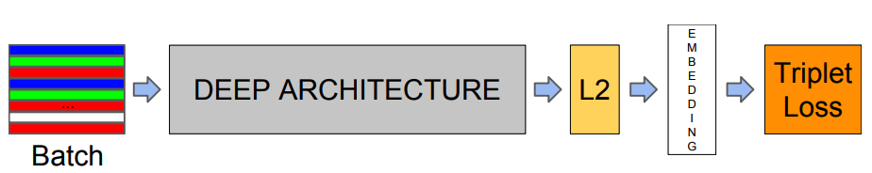

Figure 3: Model structure of FaceNet

The network is formed by a batch which stores input face images and a deep convolutional neural network (CNN), then compute a squared L2 distance normalization and results in the face embedding. At the end of the model, there is a Triplet Loss function which used to perform further classification (see Figure 4).

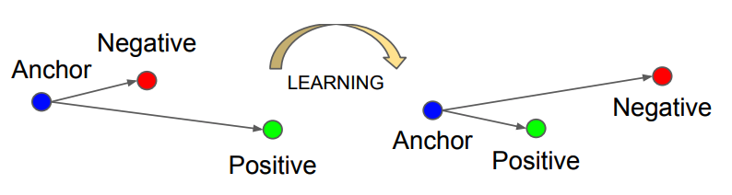

Figure 4: Workflow of Triplet Loss

Triplet Loss function consists of an anchor, a positive image and a negative image. The purpose of the Triplet Loss function is to minimize the distance between the anchor and positive image and maximize the distance between the anchor and negative image. The anchor is the current face which has identity A. The positive image is another image which also contains a face had identity A. The negative image does not have the same identity, in other words, could be a face of any person except person A. Generally speaking, both the anchor and positive image are belong to the same person while the negative image belongs to another person. The function embeds a face image $x$ into a d-dimensional Euclidean space. Then, for the anchor ($x_{i}^{a}$), positive image ($x_{i}^{p}$) and negative ($x_{i}^{n}$), it has equation (1).

 where $α$ is a margin between positive and negative pairs. $T$ is the set of all possible triplets and the batch size is N. The minimized loss is equal to equation (2).

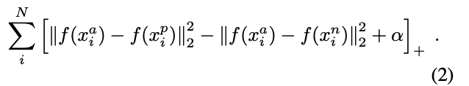

The bigger L would be selected to train the CNN using Stochastic Gradient Descent (SGD) with Zeiler & Fergus style networks [8] and Inception model [9].

As a result, the neural network is able to learn to quantify faces and return highly robust and discriminating embeddings which is suitable for face recognition. The output model will be used in this system to extract 128-dimensional embeddings for each human face inside the dataset. The embeddings can highly represent the facial features of a specific person. Furthermore, a machine learning based face recognition model can actually be trained on top of these embeddings.

### SVM

A Support Vector Machine (SVM) [10] is a discriminative classification algorithm which can handle multiple categorical and continuous variables. It can significantly divide the variables into classes. Figure 5 shows an abridged general view of SVM.

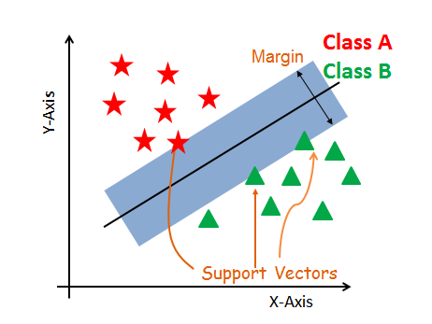

**Figure 5: General view of SVM**

Support Vectors are the points which stand for the data in the given dataset. A hyperplane is a decision plane which separates these variables into classes while a margin separates the either closest class points. The bigger the margin, the better the performance.

Scikit-learn [11] is a machine learning library provides a large number of machine learning algorithms which supports the Python programming language. It is commonly used to perform various classification and clustering algorithms. In this Video-based Automatic Attendance Checking System, Scikit-learn’s implementation of Linear Support Vector Machines will be used as a classifier which trains the face recognition model based on the extracted embeddings.

### Facial Point Annotation

For the facial point annotation, it is a facial landmark detector implemented inside dlib [12] which produces 68 points that could locate a human face in the Cartesian coordinate system. These 68 coordinates which map to specific facial structures are obtained by training a shape predictor on the labeled iBUG 300-W dataset [13]. With the help of the facial point annotation, the facial structures can be detected and extracted very accurately so that it can be used to build many amazing projects such as face alignment, face swapping and so on.

In this project, the facial point annotation will be used in the face anti-spoofing test. The very first thing which detecting eye blink would do is to locate the eyes. As shown in Figure, the left and right eyes of a human can be accessed through points No. 37 to No. 42 and No. 43 to No. 48 respectively. Then, these points would be monitored in order to track the changes of the user’s eyes in the continuous frames from the live video stream.

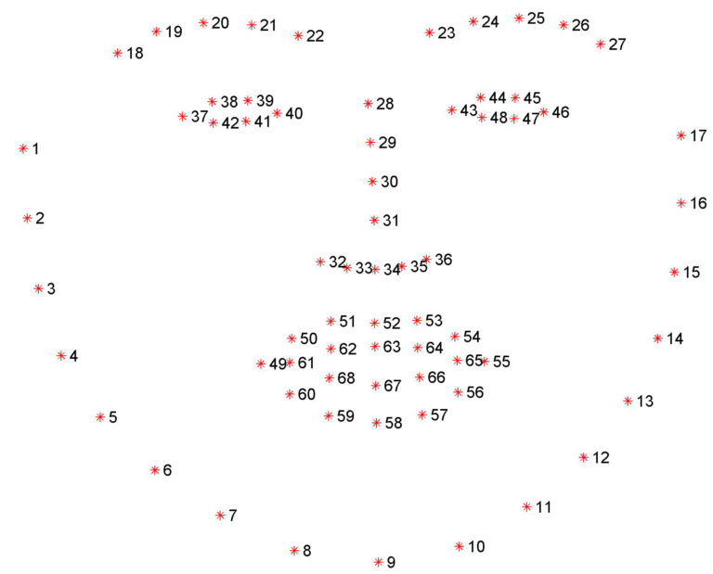

## Related Work

With the development of information technology, face recognition has been widely used in many fields in people’s daily life. For instance, Hong Kong’s border gate adopts e-Channel service [14] which is an Automated Border Control system [15] using face recognition. It uses the data stored in the chip inside the passport or ID card with biological information to verify the user’s identity. After scanning the electronic travel document, the user should stand on the foot-marked position and look at the camera for facial verification. Then the system will check if the face image stored in the chip of credential matches with the face of the person which stand in front of the camera. However, the performance is not satisfying. First of all, the speed of the facial verification process is not so rapid, and the user needs to wait for a long time until it finishes. Secondly, for the face recognition function of Hong Kong’s Automated Border Control system, it just simply compared the live video stream with the biological information generated from only one photo. Sometimes the facial verification might fail. When it happens, the process should be done by human service. Finally, it might not work well with the glasses, scarves, beard, and too much makeup.

In this project, taking as much as possible photos with different styles to build a larger dataset in order to train a powerful face recognition model is the best way to enhance the performance of the system.

At the same time, in order to prevent that some user might take attendance for other users by using other users’ photo, a face anti-spoofing test is absolutely needed. How Apple Inc. solved this kind of problems in Face ID of iPhone XS is basically relying on the hardware [16]. In the front-facing camera of iPhone XS, a dot projector can project more than 30,000 invisible dots onto user’s face to build the unique facial map and an infrared camera reads these dot patterns to detected whether there is a liveness human or not. Meanwhile, this kind of solutions requires a lot of hardware support. An infrared camera with dot projector would cost a lot and it is hard to implement. Not all the cameras could be adopted for face recognition without an infrared camera so that the universal applicability and general ubiquity would be decreased.

As a result, in this project, a face anti-spoofing test would be implemented by a human-computer interaction which requires the user to blink their eyes for certain times. It would save the budget and increase universal applicability.

# Design Approach

## System Overview

The Video-based Automatic Attendance System with Anti-spoofing is formed up by the following sections: Face Recognition Function, Face Anti-Spoofing Test, user-friendly interface, and database, as shown in Figure.

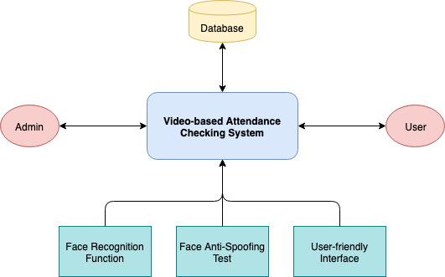

Firstly, Face Recognition Function is designed for identifying the human being which appears in the live video stream. Secondly, for the purpose of preventing someone using photos to take attendance for others which are not attending the class, Face Anti-Spoofing Test is adopted. In addition, the interface will display the live video stream and simply provide some feedback to the user. Finally, the database stores the related and necessary information used for the attendance checking.

Above all, Face Recognition Function, Face Anti-Spoofing Test, user-friendly interface, and database mainly constitute the Video-based Automatic Attendance System.

Generally speaking, the system is provided for admin and user. Admin (or teacher of the class) has two usages. One is to start up the system for students to do the attendance checking, and another one is to input some manual instructions to take attendance in order to countermeasure that the system fails to recognize some students. The user, ordinarily is the students who attending the class, needs to do an enrollment as an advanced work. And for the attendance checking process, the user only needs to sit in front of the camera and blink the eyes when the system tells the user to do so.

The detail information about the system will be discussed in the following paragraphs.

## System Workflow

Figure shows a system workflow of the project.

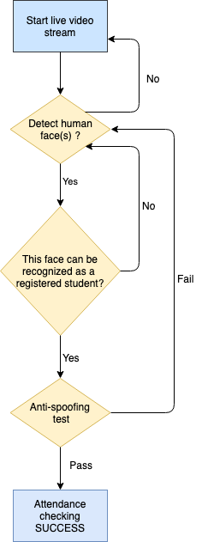

The first thing the system would do is to start the live video stream to monitor and detect whether there is a human face appears, and further check whether the face can be recognized and matches with a registered user (student). Once a face can be recognized, the anti-spoofing test would come up. For example, the system would pop up a notice such that tells the user to blink their eyes once, twice or more. If the anti-spoofing test is passed, the attendance checking for this user (student) would be successful. Otherwise, the user would need to come back to face detection and follow the whole process again until it fulfills all the requirements.

## Face Recognition Function

The Figure simply shows the process of how the face recognition function is implemented step by step.



The face recognition function consists of four sections: face enrollment, building face dataset, extracting embeddings for each enrolled face, and training face recognition model which could be used to identify target users.

In the beginning, face enrollment would require user sitting in front of the camera. For every user, show the face clearly as much as possible and avoid masking noses and mouths, wearing sunglasses, growing beard and being with too much makeup. Additionally, it is suggested to capture 40 face images with different facial expressions and manners. After detecting one (and make sure there is only one) human face appears in the video stream, this face image would be captured continuously and the suggested number of captured face image would be 40. Then, these photos would be added into a folder with this user’s name. Caffe-based deep learning face detector would help to extract the embeddings for each face. Last but not least, the embeddings and the corresponding names would be classified respectively, and the output would be a recognizer involving embeddings and a label of names which match to the embeddings.

Figure shows an overview of how face recognition function is implemented.

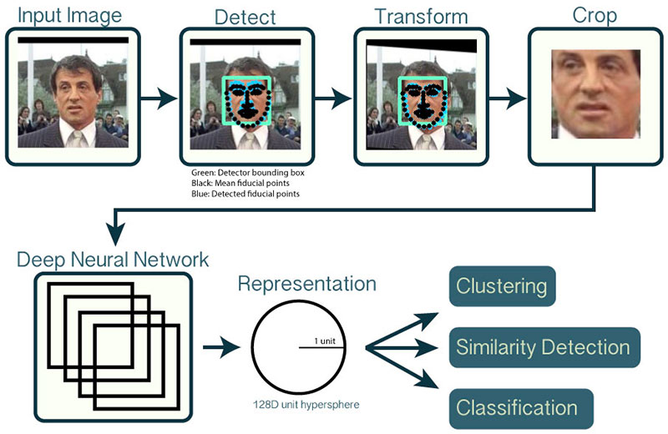

## Face Anti-Spoofing Test

In order to prevent that someone might check attendance for others by using a photo of others, face anti-spoofing test is designed. The idea is that a photo cannot perform eye blink while a real person can. Figure simply shows the process of how the face anti-spoofing test works. Firstly, the system will do face detection and locate the eyes with the help of a 68 facial landmark detector via Dlib. Then compute an eye aspect ratio (EAR) to represent left eye and right eye respectively. Lastly, if the eye aspect ratio fell below a certain threshold and then rose above the threshold, it would be recorded as a blink. The system would tell the user to blink once, twice or more times, or blink right, left or both eyes, and once the system detects exactly the same number of specific eye blinks, it will be confirmed as a real person.



## Automated Update of Face Dataset

Human’s face is more or less changing all the time. For the purpose of improving the accuracy of the face recognition function, an automated updating mechanism is needed. The idea of this is, for every time the user successfully checking the attendance, fetching some frames of face images which could be recognized correctly as the specific user and save it in the face dataset. Based on that, the system would be able to renew the face dataset so that the system can recognize the changes in the user’s appearance adaptively.

## Database Design

The database is built with MySQL [17]. In this project, there is only one fact table named *Attendance_Fact*. It stores the necessary information for attendance checking involving student’s id, student’s name, the class which the student need to attend, and whether the student attends the class. Figure shows all the detail settings of this database.

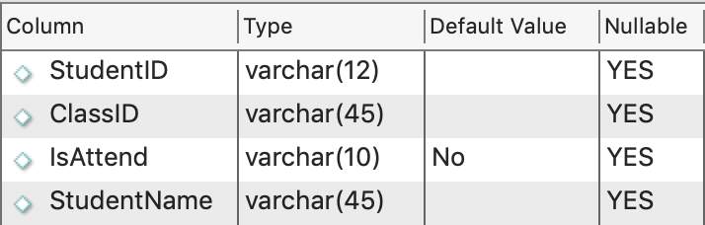

# Implementation

## Platforms

The Video-based Automatic Attendance Checking System is developed based on Python as a programming language and OpenCV library which mainly been responsible for dealing with the real-time computer vision issues. Face detection is performed based on Haar Cascade. FaceNet is adopted to extract embeddings from users faces and the classifier used to train the face recognition model is SVM (Support Vector Machine). The face anti-spoofing test is developed with the help of Facial Point Annotation via Dlib. The database of this system is built with MySQL. The user interface is designed and implemented with PyQt5 [18].

## ­Face Recognition Function

Face recognition function consists of three sections: face enrollment, embeddings extracting for each enrolled face, and training face recognition model which could be used to identify target users.

### Face Enrollment

In this section, the system will start the live video stream and capture the frames which contain the one and only specific user’s face from the threaded video stream. Haar Cascade is adopted to detect the face appears in the video stream. There should be one and only one user in front of the video stream for building his/her own dataset.

Figure shows how face detection is implemented. First of all Haar Cascade is loaded as a *detector* and a *frame* which resized to a width equal to 400 pixels is grabbed for further processing. Then, using the *detector*’s *detecMultiScale* method to detect the human face in the *frame.* The result of this face detection method is a list of bounding box rectangles (called *rects* in the Figure). Lastly, looping over all the rectangles and drawing the rectangle on the *frame* for display purposes.

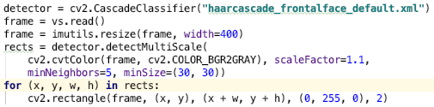

After detecting the faces, the last step is to store the frames into the hard disk. If the “k” key is pressed, the frame will be captured, and it will be stored in the system.

### Embeddings Extracting

For extracting embeddings, for every image in the face dataset, the system firstly loads a face image from the dataset into the first Blob [19] (*imageBlob*) one by one and actually locates the face in the image by passing this image blob through the OpenCV’s Caffe-based deep learning face detector. As shown in the Figure, some pretreatment should be done for fulfilling the expects of the convolutional neural network. The image is put into a 4-dimensional image blob which resized to 300*300 with 1.0 scale factor. *(104.0, 177.0, 123.0)* is the mean subtraction value in a tuple which helping to deal with illumination changes in the face images. The mean values are from ImageNet [20] training set with the RGB (Red, Green, Blue) order. The last two valuesindicate that do not swap first and last channel(red channel and blue channel) in a 3-channel image and the image will not be cropped after resizing. And this image blob would be passed through the detector and a *detection* list which contains probabilities (similarities) and coordinates to locates faces in an image would be traced back.

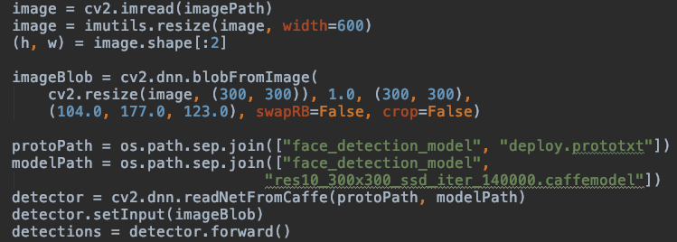

Secondly, as shown in the Figure, since there is only one face in the image, the *detection* with the highest *confidence* would be extracted by the *argmax* function from NumPy [21]. If it does not meet the minimum probability (similarity) threshold (which is 0.5 in this project), it would be filtered out. Assuming that it met that threshold, extracting the face ROI (region of interest) from the strong detections for constructing the second blob (*faceBlob*). Then, the system passes this face blob through the Torch based deep learning embedder’s convolutional neural network which is from FaceNet and the generated output will be a 128-D vector embedding which can represent a face.

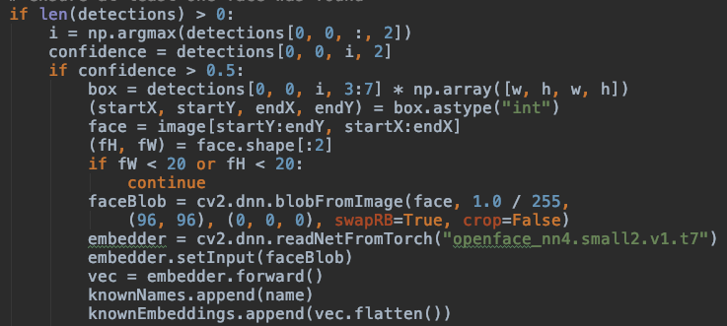

Last but not least, adding the name and the output embedding to two lists respectively. Figure shows an example in the Python shell which indicates how to extract the name from the image path.

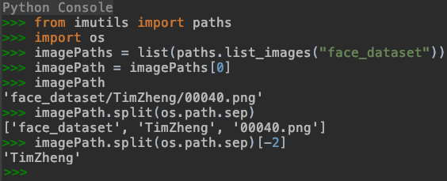

Above all, the system loops over all the images in the face dataset and serialize the embeddings with the corresponding names into a pickle file. This is the whole process of extracting the face embeddings for each user in the face dataset.

Figure 9 simply shows how OpenCV and dnn.blob module works.

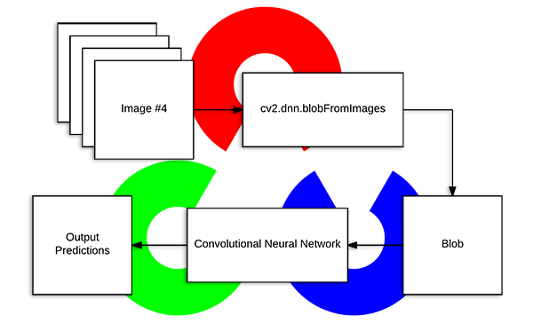**Figure 9: The workflow of OpenCV and dnn blob module**

### Train Face Recognition Model

The process of training face recognition model is straightforward. Figure shows how the classification is done. At first, load the 128-D embeddings which generated and serialized from the previous section and initialize Scikit-learn’s Label Encoder and encode the names to labels. Next, use a machine learning model called Support Vector Machine (SVM from Scikit-learn) to train the model by fitting the embeddings with the labels (names) and classify them. A recognizer with a linear kernel is used in this project. This step is simply fitting the embeddings with the corresponding name to the recognizer (also known as training the recognition model). Finally, store the output recognizer model and label of names to two pickle files respectively.

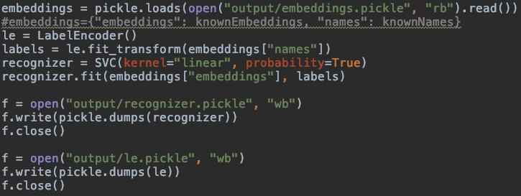

### Face Recognition Function

For the face recognition function, the system will firstly load the serialized face detector, pre-trained face embedding model, and pre-trained face recognition model along with the label of names, as shown in Figure



After that, start the live video stream and detect the human faces in the video frames. Filter out the weak detections and grab the face blob as *4.2.2* did. As shown in Figure, the face blob would be constructed and be put into the embedder and put this embedder into the recognizer in order to generate a 128-D vector which describes the face. Then, the system will pass the vector into the recognizer, the result of which is the predictions for who is in the face ROI. The index of the highest probability (similarity) of this face will be used to query the label encoder to find the name of this face.



The system will continuously monitor the video frames, once there are 9 frames which similarities are higher than 83%, the name of the user would be taken to check whether the user is in this class through comparing with the database as shown in Figure. And the reason why these 2 parameters are 9 and 83% respectively would be discussed in Section *5.1.3*. If the user could be found in the class list, it would be considered as a successful face recognition.



## Face Anti-Spoofing Test

For the protection of face photo spoofing attack, a face anti-spoofing test is adopted. The very first thing that face anti-spoofing test needs to do is to locate both the left and right eyes. The system will load the Dlib’s built-in face detector and the facial landmark predictor via Facial Point Annotation, and do some frame preprocessing which resize the frame to width equals to 600 pixels and convert the frame to grayscale. As shown in Figure, assuming that the system has detected a face in the grayscale frame, the predictor would help to determine the facial landmarks on the face region and convert these coordinates to a NumPy array with the help of imutils’ [22] face_utils function. So far, both the left and right eye can be extracted respectively.



According to Soukupová and Čech’s paper in 2016, Real-Time Eye Blink Detection using Facial Landmark [23], there is a ratio called eye aspect ratio (EAR) which can indicate an eye is either opened or closed. Based on that, the system can distinguish between the real person and a photo since that a real person’s eye aspect ratio is always changing while a photo is not. From the top-left of Figure, p1 to p6 are 2D facial landmark locations which can represent an eye. The equation is:

EAR = ( | p2 - p6 | + | p3 - p5 | ) / (2 * | p1 – p4 |)



The distance between the vertical eye landmarks is the numerator and the distance between the horizontal eye landmark is the denominator, weighing the denominator to double since there is only one set of horizontal points but two sets of vertical points. If an eye is fully opened, the EAR will approach a constant. However, once the user blinks, the EAR will decrease to zero dramatically. The bottom of Figure plots a graph of the EAR over time for a live video stream. The EAR is approaching a constant, then drops down to almost zero, then increases again, based on that can indicate a blink has taken place.

In this project, since both the eyes are located, EAR for both eyes can be computed respectively. Figure shows how to implement the function that computes the EAR. Since the array starts from zero and point p in the above figure is start from 1, eye[1] would be p2, so as the others. Back to Figure, averaging the EAR of the left eye and right eye would finally compute an EAR that stands for a user. If there are three consequent frames which the EAR is below the threshold, it will be counted as a blink.



According to Soukupová’s paper [24], the recommended threshold for a normal human being is 0.2. In addition, since the FPS (frames per second) for live video stream is 15 which means a frame last 66.6 milliseconds, and a normal human being’s eye blink lasts 200 milliseconds [25], if there are 3 consequent frames which all the thresholds are below than 0.2, then it can be considered as an eye blink.

Lastly, the system will require the user to blink several number of times where the number is produced randomly by the system. If the user blinks a certain number of times, the user would pass the face anti-spoofing test.

## Automated Update of Face Dataset

For automated update of face dataset, every time the user is recognized, the 5 of 9 frames which contains the face image of the user and the similarities are higher than 83% would be fetched in the memory. Once the user passed the anti-spoofing test, the pre-fetched 5 frames would be saved into the face dataset.

# Results and Discussion

## Results

### Result of Face Enrollment

For Face Enrollment, the system will start live video stream and perform face detection. As shown in Figure, if a human face is detected, there would be a rectangle maintains the face. The admin should confirm that the face which appears in the rectangle is the user who is doing the face enrolment. Then, press the “k” key to capture the face image, and it will be stored in the system.

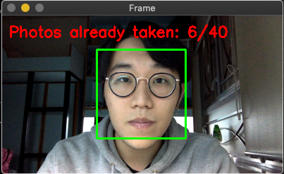

The captured photos will be numbered and stored under the subdirectory where the name of the subdirectory matches with the name of the user. Figure 8 shows the structure of the dataset storing the face images. The “Unknown” folder is used to represent the faces of people who are not the included user in this system.

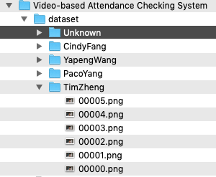

**Figure 8: Structure of the dataset storing the face images**

### Home page

Figure shows the home page of this video-based attendance check system. At the upper half of the home page, there is a spreadsheet which lists the information about the class involving student name and id, which class he/she belongs to, and whether he/she is attended. Two buttons are at the bottom of the page, “Start” and “Quit”. The “Quit” button is simply used to quit the program. If “Start” is pressed, it would start the face recognition function and it would be shown in Section *5.1.2*. After a student is recognized and pass the face anti-spoofing test, the “IsAttend” cell corresponds to this student would become “Yes” automatically.

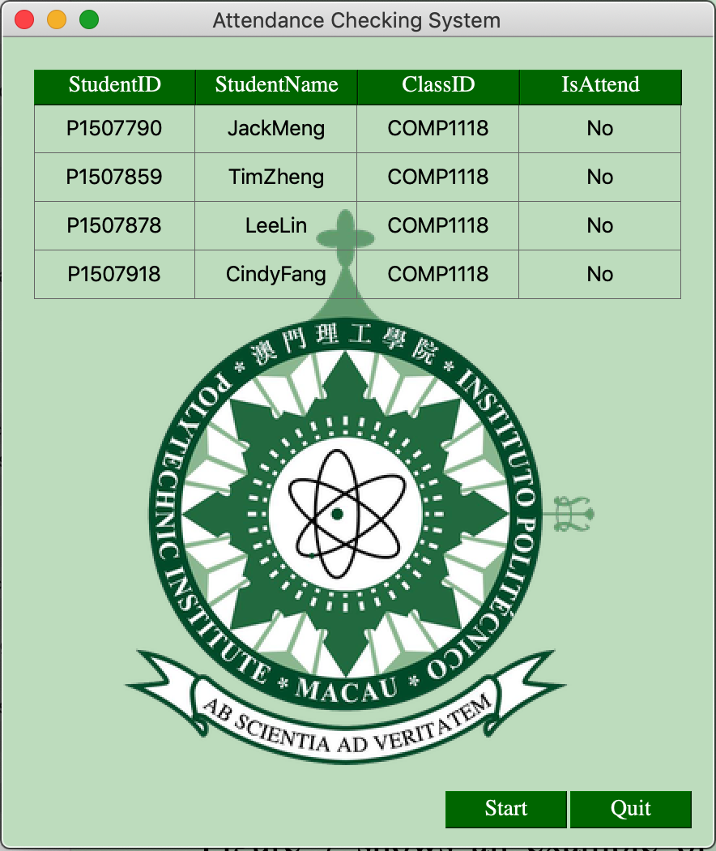

### Result of Face Recognition Function

An example of Face Recognition Function is shown in the Figure. Once a user is recognized by the system, there would be a rectangle surrounding the face with the recognized user name and the corresponding similarity and this similarity is real-time updated. The more clearly the user shows his/her face, the higher similarity the system would return.

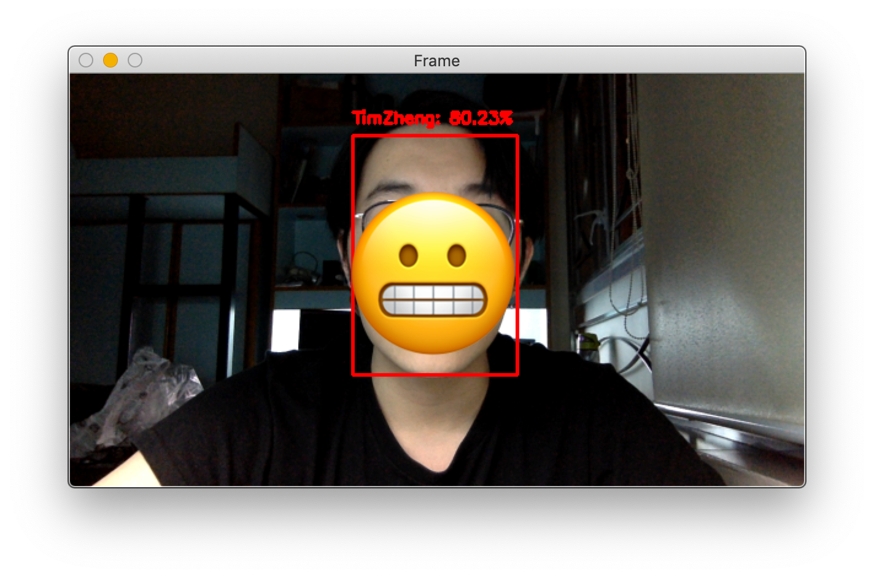

If there are 9 frames which the similarities are all higher than 83%, the user would be recognized by the system. As shown in the Figure, The whole process is taken 8 seconds.

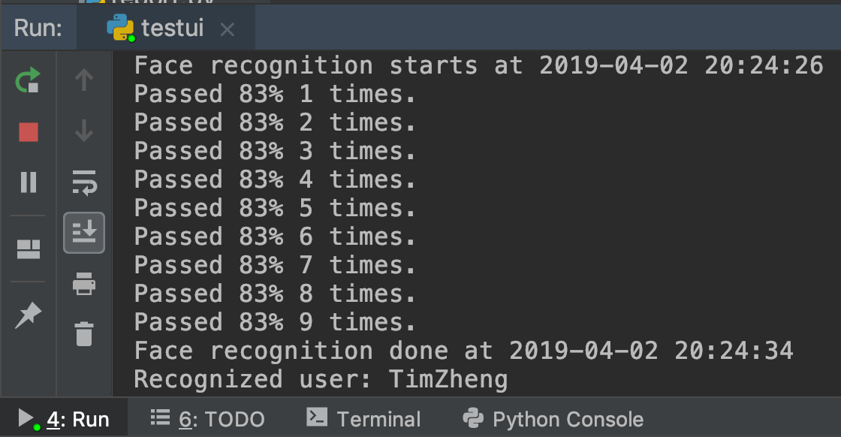

For the reason why this project adopts 9 frames and 83% similarity as the threshold, it depends on the result of a serial of experiments and adjustments is shown in Table. In order to ensure that the accuracy of the face recognition, the similarity should be higher than 83% so that all the result of the face recognition is correct. The number of frames indicates the time takes to finish the recognition. 9 frames which similarities are higher than 83% is the best option which it takes 8 seconds to finish the face recognition correctly.

|  |  |  |  |  |
| --- | --- | --- | --- | --- |
| Number of Frames  Similarity | 5 | 7 | 9 | 11 |
| 75% | 3s  Wrong | 3s  Wrong | 4s  Correct | 5s  Correct |
| 79% | 3s  Wrong | 4s  Correct | 5s  Correct | 6s  Correct |
| 83% | 5s  Correct | 6s  Correct | 8s  Correct | 11s  Correct |
| 87% | 12s  Correct | 13s  Correct | 14s  Correct | 14s  Correct |
| 91% | 15s  Correct | 15s  Correct | 16s  Correct | 18s  Correct |

### 

### Result of Face Anti-Spoofing Test

After the user (take TimZheng as an example) has been recognized, it would come to Face Anti-Spoofing Test. As shown in Figure, there is a cyan text which requires the user to blinks his/her eyes for 12 times. The number that requires the user to blink is generated randomly between 8 to 15. At the top right corner, the system shows the user how many blinks he/she has done currently. Once the user blinks 12 times, the Face Anti-Spoofing Test is passed, in other words, the whole attendance checking is completed successfully.

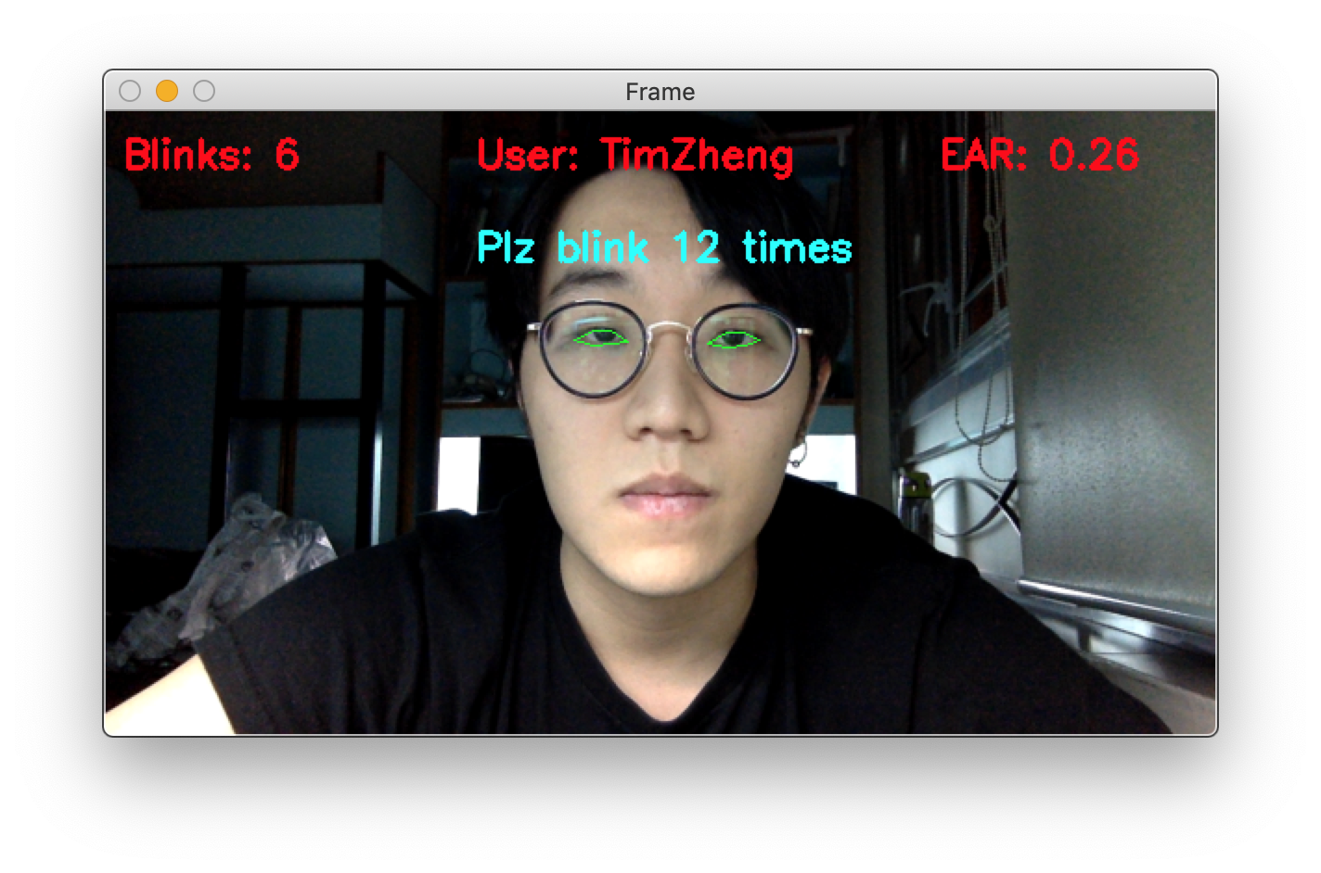

### Result of Attendance Checking

As shown in Figure, compare to Figure in *5.1.2*, the circled cell is changed to “Yes” after the user “TimZheng” successfully checking the attendance through the system.

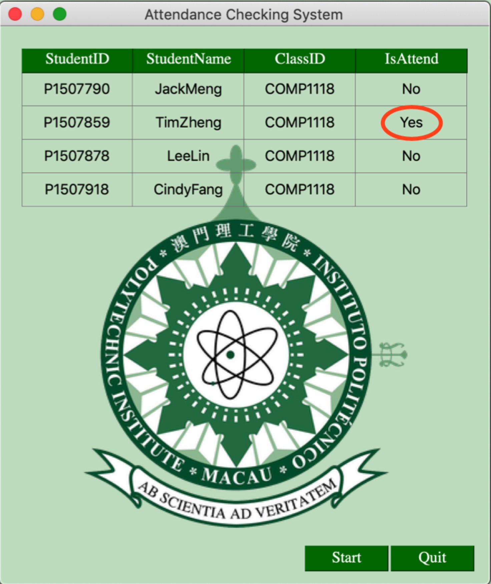

Once a user is checking the attendance through the system, the 5 of 9 frames which the similarities are higher than 83% would be saved into the face dataset for updating.

### Summary

From all the test results, the Video-based Attendance Checking System functions properly. It meets all the objectives stated in Section *1.1* and has all the functionalities specified in Section *3*.

## Discussion

There are two major advantages of this project. One of the most important features of this project is the prevention of spoofing attacks. It ensures that the user cannot check attendance for others. Since this project utilizes the human-computer interaction in the anti-spoofing test, it could be able to guarantee the liveness of users. On the other hands, the face recognition of this system is more professional and accurate since the face dataset contains 40 more photos for each user and the dataset is updated automatically. Based on that, the face data is always up to date. It makes the face recognition function more and more adaptive with the change in appearance such as hairstyle, makeup, and whether wearing glasses. Meanwhile, for the face recognition function of Hong Kong’s Automated Border Control system, it just simply compared the live video stream with the biological information generated from only one ID photo. It has a higher error rate than the face recognition function of this project.

However, the limitation of this project is the hardware issue. Since the face dataset is updated automatically, the size of the face dataset would become larger and larger. It means the time the system spends on training the face recognition model would be longer. There is also a concern about the accuracy of the eye blink detection. Due to the photographic resolution of the camera, for some users whose eyes are small, the system might not be able to locate the eyes precisely so that the eye aspect ratio might not be absolutely accurate.

# Conclusion and Further Work

## Conclusion

The Video-based Attendance Checking System consists of the following parts: Face Recognition Function, Automated Update of Face Dataset, Face Anti-Spoofing Test, Database, and an interface. First of all, for Face Recognition Function, it including Face Enrollment, Embeddings Extracting and Train Face Recognition Model. The face dataset contains 50 face photos per user. The embeddings are extracted through a convolutional neural network with the help of the previous face dataset. The face recognizer also has been trained on top of the above embeddings. And the Face Recognition Function has been able to work perfectly. Secondly, based on Automated Update of Face Dataset, the system would be able to renew the face dataset so that the system can recognize the changes in the user’s appearance adaptively. Meanwhile, the size of the face dataset which increased continuously might be a problem and it needs to be solved in the future. Moreover, Face Anti-Spoofing Test is able to prevent that someone might check attendance for others by using a photo of others. The only concern of this test is that it might take a lot of time and sometimes it might not work perfectly with small eyes due to the camera issue. In addition, the database of this project has been built successfully and it stores the necessary information for attendance checking involving student’s id, student’s name, the class which the student need to attend, and whether the student attends the class. The database can be read and updated correctly. Last but not least, the interface is designed user-friendly.

This project has achieved the following objectives: design and implement a user-friendly interface; build up a database to manage the user’s information used for attendance checking system including class name, student’s name and ID; implement the face recognition function based on live video streams in order to identify authentication; implement an approach which aims to prevent the biometric spoofing (anti-spoofing); provide adaptive recognition which can recognize the changes in the user’s appearance; reduce the time spends on attendance checking for a class.

## Further Work

This project can be improved in these parts.

The first part is expanding the face dataset from multi-dimensions. For every user, the admin could require that, when the new users enrolling their face, they could try to take photos with different expressions, with different angles, different distances between the camera, etc. Through the expansion, the accuracy of the face recognition function would be improved significantly.

The second part is to reduce the size of face dataset. Do some compression for the face images for storing purpose. When training the face recognition model, decompress the face images. Adopting this kind of storage technology can free up the storage spacing efficiently.

The last part is improving the photographic resolution of the camera, which will make the results of face recognition and eye blink detection more and more accurate. Purchase a camera with the higher resolution might be the best option.

References

[1] Facial Recognition, https://www.techopedia.com/definition/32071/facial-recognition. [Sept. 10, 2018]

[2] American Welding Society, Photo ID Requirement, https://www.aws.org/certification/page/photo-id-requirements. [Sept. 12, 2018]

[3] Background and History of Python. http://buildingskills.itmaybeahack.com/book/python-2.6/html/p01/p01c01_background.html. [Nov. 7, 2018]

[4] Ivan Culjak, David Abram, Tomislav Pribanic, Hrvoje Dzapo, Mario Cifrek. “A brief introduction to OpenCV”. Faculty of electrical engineering and computing, University of Zagreb, Zagreb, Croatia, September 2012.

[5] OpenCV, Face Detection using Haar Cascades, https://docs.opencv.org/3.4.3/d7/d8b/tutorial_py_face_detection.html. [Nov. 10, 2018]

[6] Deep Neural Network, https://www.techopedia.com/definition/32902/deep-neural-network. [Nov. 7, 2018]

[7] Florian Schroff, James Philbin, Dmitry Kalenichenko. “FaceNet: A Unified Embedding for Face Recognition and Clustering.” IEEE Conference on Computer Vision and Pattern Recognition (CVPR), 2015.

[8] M. D. Zeiler and R. Fergus. Visualizing and understanding convolutional networks. CoRR, abs/1311.2901, 2013. 2, 4, 6

[9] C. Szegedy, W. Liu, Y. Jia, P. Sermanet, S. Reed, D. Anguelov, D. Erhan, V. Vanhoucke, and A. Rabinovich. Going deeper with convolutions. CoRR, abs/1409.4842, 2014. 2, 4, 5, 6, 9

[10] DataCamp, Support Vector Machines with Scikit-learn, https://www.datacamp.com/community/tutorials/svm-classification-scikit-learn-python#svm. [Nov. 14, 2018]

[11] OReilly Media, Introduction to Scikit-learn, https://www.oreilly.com/ideas/intro-to-scikit-learn. [Nov. 11, 2018]

[12] Dlib, dlib.net. [Mar. 13, 2019]

[13] C. Sagonas, E. Antonakos, G, Tzimiropoulos, S. Zafeiriou, M. Pantic. 300 faces In-the-wild challenge: Database and results. Image and Vision Computing (IMAVIS), Special Issue on Facial Landmark Localisation "In-The-Wild". 2016.

[14] GovHK, e-Channel Service for Visitors, https://www.immd.gov.hk/hks/services/echannel_visitors.html#sd. [Sept. 11, 2018]

[15] NEC, Automated Border Control, https://hk.nec.com/en_HK/pdf/solutions/DLFE-1309.pdf. [Sept. 11, 2018]

[16] Face ID, iPhone XS, Apple Inc. https://www.apple.com/iphone-xs/face-id/. [April. 1, 2019]

[17] MySQL 5.7 Reference Manual, MySQL, https://dev.mysql.com/doc/refman/5.7/en/. [Mar. 10, 2019]

[18] PyQt5 Reference Guide, PyQt5, http://pyqt.sourceforge.net/Docs/PyQt5/introduction.html/. [Mar. 10, 2019]

[19] Learn OpenCV, Blob Detection Using OpenCV, https://www.learnopencv.com/blob-detection-using-opencv-python-c/. [Nov. 10, 2018]

[20] About ImageNet, IMAGENET, http://image-net.org/about-overview/. [Feb. 23, 2019]

[21] Numpy.argmax, SciPy.org, https://docs.scipy.org/doc/numpy/reference/generated/numpy.argmax.html. [Feb. 23, 2019]

[22] Imutils, https://pypi.org/project/imutils/. [Mar. 11, 2019]

[23] Tereza Soukupova and Jan Cech, “Real-Time Eye Blink Detection using Facial Landmarks”. Center for Machine Perception, Department of Cybernetics, Faculty of Electrical Engineering, Czech Technical University in Prague, February 3-5, 2016.

[24] Tereza Soukupova, “Eye-Blink Detection Using Facial Landmarks”. Center for Machine Perception, Department of Cybernetics, Faculty of Electrical Engineering, Czech Technical University in Prague, May 26, 2016.

[25] Anne Mandel, Siiri Helokunnas, Elina Pihko and Riitta Hari. “Neuromagnetic brain responses to other person’s eye blinks seen on video”, Brain Research Unit, O.V. Lounasmaa Laboratory and MEG Core, Aalto NeuroImaging, Aalto University, 2014.

[15] Chingovska, Ivana & Erdogmus, Nesli & Anjos, André & Marcel, Sébastien. “Face Recognition Systems Under Spoofing Attacks”, Face Recognition Across the Imaging Spectrum, P165-194, 2016.

[17] Dlib C++ Library, Introduction, www.dlib.net/intro.html. [Nov. 11, 2018]

[18] Yaojie Liu, Amin Jourabloo, Xiaoming Liu. “Learning Deep Models for Face Anti-Spoofing: Binary or Auxiliary Supervision”. Proceeding of IEEE Computer Vision and Pattern Recognition (CVPR 2018), Salt Lake City, UT, Jun. 2018.

Appendix A. Project Management

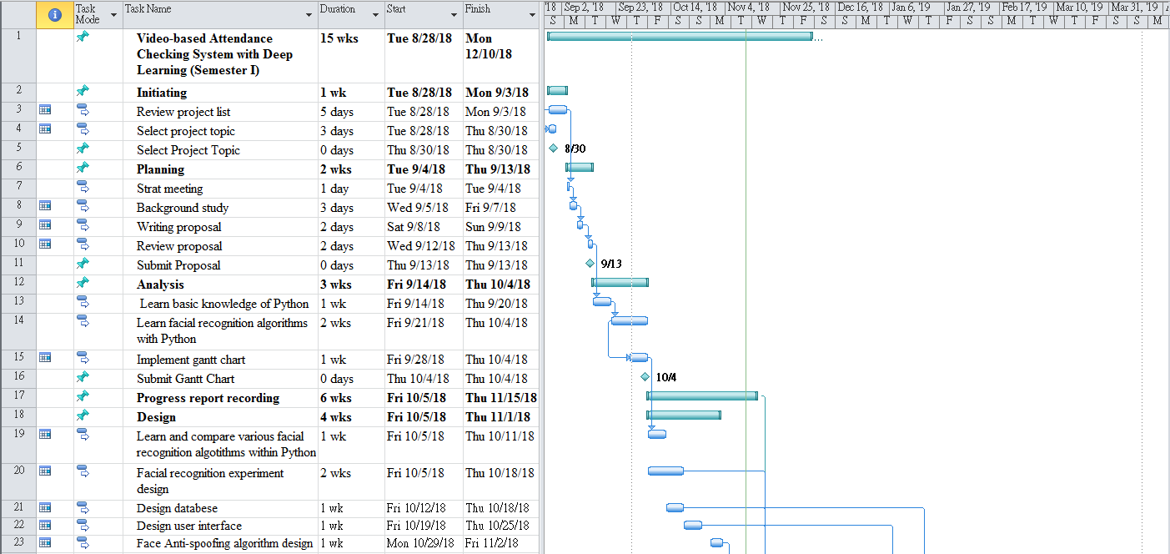

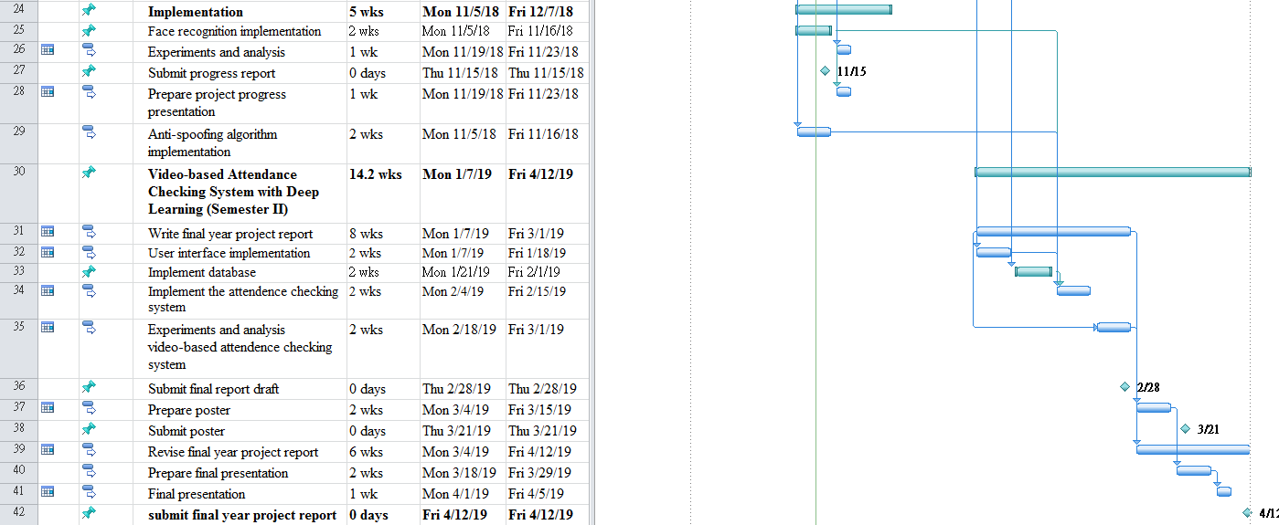

Appendix B. Reflection

Last summer, when I started to prepare this project, I had no idea about the whole project. With the help of my supervisor, I began to analyse the requirements of the project. Throughout the project implementation process, my supervisor always supports and helps me to improve my implementation as perfect as possible.

Initially, I planned to use Raspberry PI as the platform for this project. Raspberry PI is a single-board computer It took me a lot of time to study and set up the development environment in Raspberry PI. Unfortunately, when I implemented the face recognition function in it, the performance of the live video stream is not quite satisfactory. The FPS (frames per second) which around 4 is too low to make it operate smoothly. During this, two months had been passed. After discussing with my supervisor, we decided to change the platform to Macbook Pro and it works perfectly.

Through this project, I have a better understanding about the programming languages such as Python and MySQL. Also, I become more familiar with the neural network of machine learning and some supporting libraries like OpenCV, Dlib. Moreover, the most important thing I have learnt which could benefit for life is the way of thinking when I facing a problem. When I met some difficulties, I would analyze the key issues and try every solution until it fixed.

This final year project is the first project I completed the whole project by myself, it is an important experience for me.

Appendix C. Program source code / UML diagram, etc

Not compulsory